# CSE 434 – ADVANCED UNIX PROGRAMMING HOMEWORK-1

We created struct for customer,officer. In addition, we created 2 struct: Node and Node1.

For Node struct: A queue we put on customers' requests

We opened delQueue() method to delete the officer from the queue. The customer will add requests to the queue and officer delete the empty ones. The officer makes a separate queue after the request is cleared. All transactions done on this queue.

We provided communication using semaphores and mutexes.

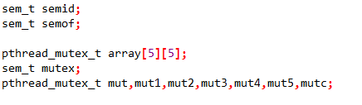

We used the semaphore so that the customer can not add work while there are no officer members in the queue and so that all the staff were full while the customers waited.

We used a mutex when making a change in shared memory.

We created separate mutex for each company and each flight and we used mutex array.

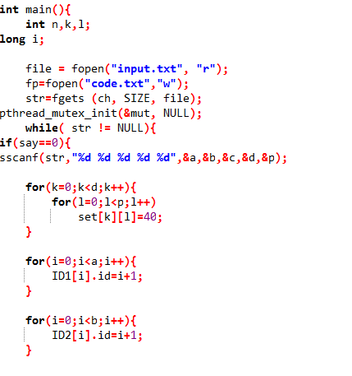

We read the first line values from the file and assigned an id according to it. After we created threads.

